
My name Is Kylan Hill. I was born February 13th. I have five siblings including two girls and three boys. My family is initially from Tallahassee, FL and outskirts all over Florida but I’m from Macon, Ga. A City down south about an hour and a half from Atlanta. We stayed in Florida a lot as I was growing up as a kid. I have family in Panama City, Tampa, Jacksonville, Tallahassee and Kareyville.

I am a freshman at Georgia State University located in Atlanta. My major is general studies as of now because I am undecided. Ga State didn’t have my intended major which was mechanical engineering. I now must transfer to another school to pursue my major and work on my career.

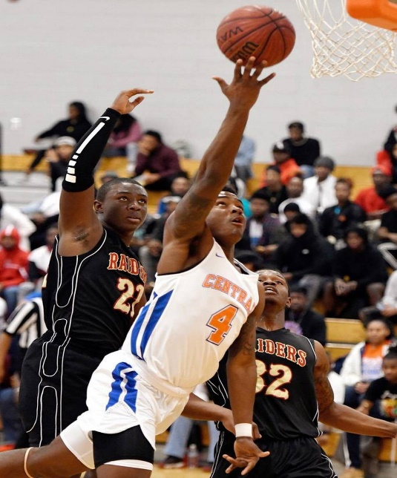
I have hobbies like basketball and fishing. I was supposed to be on a scholarship to play basketball, but I suffered from a few injuries that caused me to sit out for a season. I fractured my patella and had severe tendinitis in both knees. Basketball helps me get through a lot. I’ve also dealt with tendinitis.

